Hamlyn Views School

Accident and Incident Reporting Policy
Help for non-English speakers
If you need help to understand the information in this policy please contact Hamlyn Views School on (03)52155700

- PURPOSE
All students and staff have a fundamental right to be safe at our school. On the rare occasion where accidents, incidents or near-misses occur, these will be documented with the intention of preventing them from occurring in the future.
- AIMS
- To provide clear processes for documenting accidents, incidents and near-misses.
- To adhere to DET policy and guidelines for managing the reporting of student and staff accidents, incidents and near-misses.
- IMPLEMENTATION
- When an accident, incident or near-miss occurs the following action should be undertaken by the nearest staff member:
- Administer first aid as required with the assistance of the School Nurse or a trained Level 2 First Aid staff member.
- Seek assistance from nearby staff or school leadership as necessary.
- Notify the principal or their delegate if any serious accident or incident occurs.
- Complete all written documentation using online reporting system and/or provide to the office as soon as possible.
- Accidents and incidents of a minor accident will be recorded in the school First Aid Booklet (located in the Sick Bay). A copy will be sent home to parents.
- All accidents and incidents involving more serious injury to students must be entered online in the injury management system on CASES21 using the ‘Student Incident Notification Form’ and parents /carers notified promptly.
- Injuries to staff must be entered into the EduSafe program www.eduweb.vic.gov.au/EduSafe/
- Visitors and contractors who are unable to access EduSafe should fill out the ‘Incident and Hazard Report Form’ for the Business Manager to enter on EduSafe on their behalf.
- Serious accidents, incidents or near-misses should be reported to the Incident Support and Operations Centre (ISOC) on 1800 126 126
- As a general rule, a serious incident is one that requires medical attention or a police investigation. More information can be found on the following link: https://www.education.vic.gov.au/school/principals/spag/management/pages/reporting.aspx
- If a serious workplace injury has occurred, immediately after becoming aware the Principal or their delegate must contact the Worksafe 24 hour emergency line on 132360 to make a report. Refer to Notifiable Incident to Worksafe Flowchart http://www.education.vic.gov.au/hrweb/Documents/OHS/incidentnotificationflowchart.docx
- The Incident Notification Form must be completed and sent to Worksafe within the following 48 hours. https://www.worksafe.vic.gov.au/pages/safety-and-prevention/health-and-safety-topics/incident-notification
- The Principal or their delegate must ensure the incident scene is not disturbed until an inspector arrives. Sites can only be disturbed to protect a person’s health or safety, help someone who is injured or to make the site safe.
- General incidents of student behaviour will be recorded on COMPASS.
- In an emergency, where student behaviour poses an imminent threat of physical harm to self or others, and results in the use of restraint or seclusion, this must be reported to Incident Support Operations Centre (ISOC) Ph: 1800 126 126. A written record documenting the incident must also be made. Refer to Restraint and Seclusion: Response and Recovery Checklist and Record Sheet (Appendix A)
- Staff will be provided with support after a serious incident and a debrief as required to analyse and understand what happened, why it may have happened, and to discuss and develop strategies to implement that may produce better outcomes for student and staff health, safety and wellbeing in the future.
- Staff will also be encouraged to access DET’s Employee Assistance Program for confidential counselling as they feel necessary.

- REFERENCES AND RESOURCES
- HVS Critical Incident Plan (Emergency Management Plan).
- HVS First Aid Policy
- Occupational violence and aggression policy
- Occupational violence and aggression flowchart
- DET Occupational Violence an Aggression in Schools Policy, Procedure, Risk Controls, Resources, Advice and Supports, including Post-Incident Checklist
- Policy, Guidance, Procedures and Resources for the Reduction and Elimination of Restraint and Seclusion in Victorian Government School http://www.education.vic.gov.au/school/teachers/studentmanagement/Pages/behaviourofconcern.aspx
- DET Sensory Room Policy
- Employee Assistance Program Ph: 1300 361 008

- EVALUATION
Policy last reviewed | July, 2020
Approved by | Principal
Next scheduled review date | 2024 - this policy has a review cycle of 4 years as part of the school’s four yearly review cycle

RESTRAIINT AND SECLUSION: Response and Recovery Checklist
The following checklist outlines steps schools should take after an incident where physical restraint or seclusion of a student has occurred. These actions should be taken after immediate safety and wellbeing issues have been addressed, including administering first aid as appropriate to any student or staff member who has been injured and contacting emergency services if required.
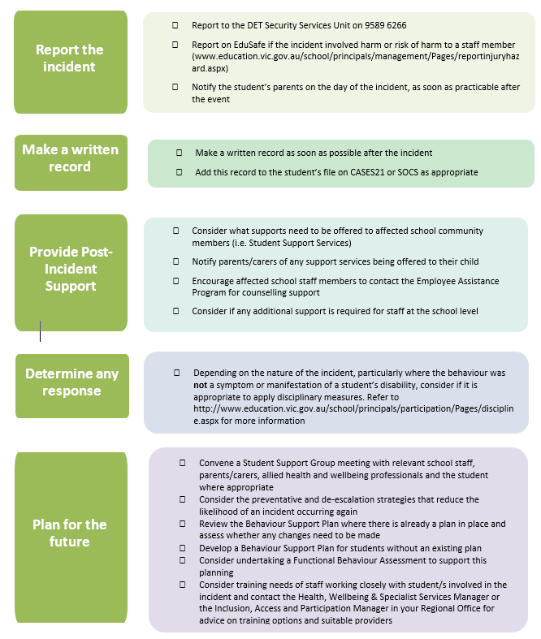
Additional Notes:
- Contact of parents/carers should be made by a member of the school’s Leadership Team where practical.
- Provide parents/carers with information about DET’s Restraint and Seclusion Policy.
RESTRAINT AND SECLUSION RECORD
This record must be attached to the student’s Compass Chronicle and a hardcopy put in their central file.
Student’s Name: | Staff members involved:
Date of Incident: | Time of Incident:
Incident Location:

Witnesses (Staff and other students):

What happened (Brief factual account):

Action taken to de-escalate the situation:

Why student was left alone in a room and unable to leave (Seclusion) for a period of time:
(If applicable)

Why physical intervention was used (If applicable):

The nature of any physical intervention:

How long the physical intervention lasted:

The students response and the outcome of the incident:

Any injuries or damage to property:

Name of Witnesses (Staff and other Students):

Witness Name: | Type: Student Staff Other
Witness Statement:

Witness Name: | Type: Student Staff Other
Witness Statement:

Witness Name: | Type: Student Staff Other
Witness Statement:

Immediate Post Incident Actions (First aid, contact with Emergency Services or other relevant professionals and agencies e.g. Child Protection, DHHS)
- Details of contact with the student's parent/carer:
- Details of any post-incident support provided or organised, including a functional behaviour assessment.

