Hamlyn Views School

Anaphylaxis Management Policy
Help for non-English speakers
If you need help to understand the information in this policy please contact Hamlyn Views School on (03)52155700

- PURPOSE
To explain to Hamlyn Views School parents, carers, staff and students the processes and procedures in place to support students diagnosed as being at risk of suffering from anaphylaxis. This policy also ensures that Hamlyn Views School is compliant with Ministerial Order 706 and the Department’s guidelines for anaphylaxis management.
Anaphylaxis is a severe, rapidly progressive allergic reaction that involves various areas of the body simultaneously and is potentially life threatening.

- SCOPE
This policy applies to:
- all staff, including casual relief staff and volunteers
- all students who have been diagnosed with anaphylaxis, or who may require emergency treatment for an anaphylactic reaction, and their parents and carers.
- POLICY
School Statement
Hamlyn Views School will fully comply with Ministerial Order 706 and the associated guidelines published by the Department of Education and Training.
Anaphylaxis
Anaphylaxis is a severe allergic reaction that occurs after exposure to an allergen. The most common allergens for school-aged children are nuts, eggs, cow’s milk, fish, shellfish, wheat, soy, sesame, latex, certain insect stings and medication.
Symptoms
Signs and symptoms of a mild to moderate allergic reaction can include:
- swelling of the lips, face and eyes
- hives or welts
- tingling in the mouth.

Signs and symptoms of anaphylaxis, a severe allergic reaction, can include:
- difficult/noisy breathing
- swelling of tongue
- difficulty talking and/or hoarse voice
- wheeze or persistent cough
- persistent dizziness or collapse
- student appears pale or floppy
- abdominal pain and/or vomiting.
Symptoms usually develop within ten minutes and up to two hours after exposure to an allergen, but can appear within a few minutes.
Treatment
Adrenaline given as an injection into the muscle of the outer mid-thigh is the first aid treatment for anaphylaxis.
Individuals diagnosed as being at risk of anaphylaxis are prescribed an adrenaline autoinjector for use in an emergency. These adrenaline autoinjectors are designed so that anyone can use them in an emergency.

Individual Anaphylaxis Management Plans
All students at Hamlyn Views School who are diagnosed by a medical practitioner as being at risk of suffering from an anaphylactic reaction must have an Individual Anaphylaxis Management Plan. When notified of an anaphylaxis diagnosis, the principal of Hamlyn Views School is responsible for developing a plan in consultation with the student’s parents/carers.
Where necessary, an Individual Anaphylaxis Management Plan will be in place as soon as practicable after a student enrols at Hamlyn Views School and where possible, before the student’s first day.
Parents and carers must:
- obtain an ASCIA Action Plan for Anaphylaxis from the student’s medical practitioner and provide a copy to the school as soon as practicable
- immediately inform the school in writing if there is a relevant change in the student’s medical condition and obtain an updated ASCIA Action Plan for Anaphylaxis
- provide an up-to-date photo of the student for the ASCIA Action Plan for Anaphylaxis when that Plan is provided to the school and each time it is reviewed
- provide the school with a current adrenaline autoinjector for the student that has not expired;
- participate in annual reviews of the student’s Plan.
Each student’s Individual Anaphylaxis Management Plan must include:
- information about the student’s medical condition that relates to allergies and the potential for anaphylactic reaction, including the type of allergies the student has
- information about the signs or symptoms the student might exhibit in the event of an allergic reaction based on a written diagnosis from a medical practitioner
- strategies to minimise the risk of exposure to known allergens while the student is under the care or supervision of school staff, including in the school yard, at camps and excursions, or at special events conducted, organised or attended by the school
- the name of the person(s) responsible for implementing the risk minimisation strategies, which have been identified in the Plan
- information about where the student's medication will be stored
- the student's emergency contact details
- an up-to-date ASCIA Action Plan for Anaphylaxis completed by the student’s medical practitioner.
Review and updates to Individual Anaphylaxis Management Plans
A student’s Individual Anaphylaxis Management Plan will be reviewed and updated on an annual basis in consultation with the student’s parents/carers. The plan will also be reviewed and, where necessary, updated in the following circumstances:
- as soon as practicable after the student has an anaphylactic reaction at school
- if the student’s medical condition, insofar as it relates to allergy and the potential for anaphylactic reaction, changes
- when the student is participating in an off-site activity, including camps and excursions, or at special events including fetes and concerts.
Our school may also consider updating a student’s Individual Anaphylaxis Management Plan if there is an identified and significant increase in the student’s potential risk of exposure to allergens at school.

Location of plans and adrenaline autoinjectors
A copy of each student’s Individual Anaphylaxis Management Plan will be stored with their ASCIA Action Plan for Anaphylaxis in the first aid folders in classrooms. Whilst some students keep their adrenaline autoinjector on their person, medication for those that do not will be stored and labelled with their name in first aid cupboards in classrooms.
Location | Adrenaline Auto-injector Location | Student’s Action Plan Location
Administration Building | First Aid Room | Staff Lounge  Front office  First Aid Room  General Office
Primary Learning Community | n/a | Classroom  Staff Workroom Shelf
Secondary Learning Community | Staff Workroom B | Classroom  Staff Workroom Shelf  First Aid Room

Risk Minimisation Strategies
The school will ensure that risk minimisation and prevention strategies are in place for all relevant in-school and out-of-school settings which include (but are not limited to) the following:
- during classroom activities (including class rotations, specialist and elective classes)
- Between classes and other breaks
- In Canteens
- During recess and lunchtimes
- Before and after school
- Special events including incursions, sports, cultural days, fetes or class parties, excursions and camps.

IN-SCHOOL SETTINGS
Classrooms
1 | Copy of students’ Individual Anaphylaxis Management Plans are displayed in their classrooms, First Aid Room, Staff Room and Canteen.
2 | Liaise with parents/carers about food-related activities ahead of time.
3 | Use non-food rewards or treats where possible, but if food treats are used on special occasions, it is recommended that parents/carers of students with food allergies provide a box with alternative treats. Treats must be clearly labelled and only handled by the student.
4 | NEVER give food from outside sources to a student who is at risk of anaphylaxis.
5 | Treats for the other students in the class should not contain the substance to which the student is allergic.
6 | Products labelled ‘may contain traces of nuts’ should not be served to students allergic to nuts. Products labelled ‘may contain milk or egg’ should not be served to students with milk or egg allergy.
7 | Awareness of possible of hidden allergens in food and other substances used in cooking, food technology, science activities, and art classes.
8 | Ensure all cooking utensils, preparation dishes, plates, knives etc., are washed and cleaned thoroughly after preparation of food and cooking.
9 | Regular discussions with students about the importance of washing hands, eating their own food and not sharing food.
10 | All CRT folders should contain the student’s Individual Anaphylaxis Management Plan. The Assistant Principal/First Aid Coordinator should inform relief staff and volunteers of the names of students at risk of anaphylaxis, the location of each student’s Individual Anaphylaxis Management Plan, the location of Adrenaline Auto-injectors, the schools’ Anaphylaxis Management Policy, and people’s responsibility in managing an incident.
Canteen (When in operation at our school)
1 | Canteen staff should be trained in food allergen management and its implications on food-handling practices, including knowledge of the major food allergens triggering anaphylaxis, cross-contamination issues specific to food allergy, label reading etc.
2 | - Canteen staff are briefed about students at risk of anaphylaxis and where the Principal determines, have up to date training in an Anaphylaxis Training Course.
3 | - Display the student’s name and photo in the Canteen as a reminder to staff.
4 | - Products labelled ‘may contain traces of nuts’ should not be served to students allergic to nuts.
5 | Canteen provides a range of healthy meals/products that exclude peanut or other nut products in the ingredient list.
6 | - Benches and surfaces are sanitised daily.
7 | No sharing of food approach is adopted.
8 | Awareness of contaminating other foods when preparing, handling or displaying food.
School Grounds
1 | - Sufficient supervision of a student who is at risk of anaphylaxis by a staff member who is trained in the administration of an Adrenaline Auto-injector.
2 | Adrenaline Auto-injectors and Individual Anaphylaxis Plans are easily accessible from the school grounds.
3 | A Communication Plan is in place for staff on yard duty so medical information can be retrieved quickly and all staff are aware how to inform the First Aid Coordinator if an anaphylactic reaction occurs during recess or lunchtime.
4 | Yard duty staff can identify those students at risk of anaphylaxis.
5 | Students with anaphylactic responses to insects are encouraged to stay away from water or flowering plants.
6 | Lawns are mowed regularly and outdoor bins covered.
7 | Students encouraged to keep drinks and food covered while outdoors.
Special Events
1 | - Sufficient staff supervising the special event are trained in the administration of an Adrenaline Auto-injector.
2 | Minimise the use of food in activities or games.
3 | Consult parents/carers in advance for special events to either develop an alternative food menu or request they send a meal for the student at risk.
4 | Parents/carers of other students should be informed in advance about foods that may cause allergic reactions in students at risk of anaphylaxis and request that they avoid providing students with treats whilst they are at a special school event.
5 | Party balloons should not be used if any student is allergic to latex.
6 | Visitors to the school who provide activities for students (e.g. science incursions) are to be informed of any students at risk of anaphylactic reactions.
OUT-OF-SCHOOL SETTINGS
- Field trips, excursions, sporting events
1 | - Sufficient staff trained in the administration of an Adrenaline Auto-injector to attend.
2 | Appropriate methods of communication must be discussed.
3 | Identify the location of the Adrenaline Auto-injector i.e. Who will carry it? How will it be delivered to the student?
4 | Individual Anaphylaxis Management Plans and Adrenaline Auto-injectors are to be easily accessible and staff must be aware of their location.
5 | Risk assessment of the activity must be completed prior to departure.
6 | Teacher in Charge should consult parents/carers of students at risk of anaphylaxis in advance to discuss issues that might arise, to develop an alternative food menu or request the parents/carers provide a meal (if required).
7 | Review Individual Anaphylaxis Management Plans prior to departure to ensure that it is up to date and relevant to the particular excursion or activity.
8 | Students who are at risk from insect bites and stings should be encouraged to wear appropriate protective clothing.
9 | First Aid Kits and mobile phones will be taken on every out-of-school activity.
Camps
1 | The school attempts to only use providers/operator services who can provide food that is safe for anaphylactic students.
2 | The Teacher in Charge will conduct a risk assessment and develop a risk management strategy for students (in consultation with parents and camp operators) at risk of anaphylaxis to ensure appropriate risk minimisation strategies are in place.
3 | The school will consider alternative means of providing food for at risk students on camp if there are any concerns about the food being safe for students at risk of anaphylaxis.
4 | The use of substances containing allergens will be avoided where possible
5 | The student's Adrenaline Auto-injector, Individual Anaphylaxis Management Plan, including the ASCIA Action Plan for Anaphylaxis, and a mobile phone must be taken on camp. If there is no mobile phone access, alternative methods e.g. satellite phone will be considered.
6 | Adrenaline Auto-injectors should remain close to the students and staff must be aware of its location at all times.
7 | Students with anaphylactic responses to insects should wear closed shoes and long-sleeved garments when outdoors and be encouraged to stay away from water or flowering plants.
8 | General Use Adrenaline Auto-injectors are included in camp First Aid Kits.
9 | Consider potential exposure to allergens when consuming food during travel on buses/plane etc. and whilst in cabins/tents/dormitories.
10 | Cooking, and art and craft games, should not involve the use of known allergens.
OTHER
Work Experience Students
1 | The school will involve parents/carers and the student in discussions regarding risk management prior to a student at risk of anaphylaxis attending Work Experience at the school. The school must be shown the ASCIA Action Plan for Anaphylaxis and their Adrenaline Auto-injector presented as a precaution whilst on work experience at the school.
Pre-Service Teachers
1 | The school will involve Pre-Service Teachers at risk of anaphylaxis in discussions regarding risk management prior to commencing a school placement. The school must be shown the ASCIA Action Plan for Anaphylaxis and their Adrenaline Auto-injector presented as a precaution whilst on placement at the school.

To reduce the risk of a student suffering from an anaphylactic reaction at Hamlyn Views School, we have put in place the following strategies:
- staff and students are regularly reminded to wash their hands after eating;
- students are discouraged from sharing food
- gloves must be worn when picking up papers or rubbish in the playground;
- groups will be informed of allergens that must be avoided in advance of class parties, events or birthdays
- Planning for off-site activities will include risk minimisation strategies for students at risk of anaphylaxis including supervision requirements, appropriate number of trained staff, emergency response procedures and other risk controls appropriate to the activity and students attending.

Adrenaline autoinjectors for general use
Hamlyn Views School will maintain a supply of adrenaline autoinjectors for general use, as a back-up to those provided by parents and carers for specific students, and also for students who may suffer from a first time reaction at school.
Adrenaline autoinjectors for general use will be stored at First Aid Room and Secondary Staff Workroom B and labelled “general use”.
The principal is responsible for arranging the purchase of adrenaline autoinjectors for general use, and will consider:
- the number of students enrolled at Example School at risk of anaphylaxis
- the accessibility of adrenaline autoinjectors supplied by parents
- the availability of a sufficient supply of autoinjectors for general use in different locations at the school, as well as at camps, excursions and events
- the limited life span of adrenaline autoinjectors, and the need for general use adrenaline autoinjectors to be replaced when used or prior to expiry.

Emergency Response
In the event of an anaphylactic reaction, the emergency response procedures in this policy must be followed, together with the school’s general first aid procedures, emergency response procedures and the student’s Individual Anaphylaxis Management Plan.
A complete and up-to-date list of students identified as being at risk of anaphylaxis is maintained by Leanne Treloar, the school nurse, and stored at the front administration office. For camps, excursions and special events, a designated staff member will be responsible for maintaining a list of students at risk of anaphylaxis attending the special event, together with their Individual Anaphylaxis Management Plans and adrenaline autoinjectors, where appropriate.
If a student experiences an anaphylactic reaction at school or during a school activity, school staff must:
Step | Action
- Lay the person flat
- Do not allow them to stand or walk
- If breathing is difficult, allow them to sit
- Be calm and reassuring
- Do not leave them alone
- Seek assistance from another staff member or reliable student to locate the student’s adrenaline autoinjector or the school’s general use autoinjector, and the student’s Individual Anaphylaxis Management Plan, stored either on their person or in first aid folders in the classrooms
- If the student’s plan is not immediately available, or they appear to be experiencing a first time reaction, follow steps 2 to 5
Administer an EpiPen or EpiPen Jr (if the student is under 20kg)
- Remove from plastic container
- Form a fist around the EpiPen and pull off the blue safety release (cap)
- Place orange end against the student’s outer mid-thigh (with or without clothing)
- Push down hard until a click is heard or felt and hold in place for 3 seconds
- Remove EpiPen
- Note the time the EpiPen is administered
- Retain the used EpiPen to be handed to ambulance paramedics along with the time and date of administration
 | Call an ambulance (000)
 | If there is no improvement or severe symptoms progress (as described in the ASCIA Action Plan for Anaphylaxis), further adrenaline doses may be administered every five minutes, if other adrenaline autoinjectors are available.
 | Contact the student’s emergency contacts.

If a student appears to be having a severe allergic reaction, but has not been previously diagnosed with an allergy or being at risk of anaphylaxis, school staff should follow steps 2 – 5 as above.

Communication Plan
This policy will be available on the Hamlyn Views School website so that parents and other members of the school community can easily access information about Hamlyn Views School’s anaphylaxis management procedures. The parents and carers of students who are enrolled at Hamlyn Views School and are identified as being at risk of anaphylaxis will also be provided with a copy of this policy.
The principal is responsible for ensuring that all relevant staff, including casual relief staff, canteen staff and volunteers are aware of this policy and Hamlyn Views School procedures for anaphylaxis management. Casual relief staff and volunteers who are responsible for the care and/or supervision of students who are identified as being at risk of anaphylaxis will also receive a verbal briefing on this policy, their role in responding to an anaphylactic reaction and where required, the identity of students at risk and this policy will be included in volunteer/CRT induction packs.
The principal is also responsible for ensuring relevant staff are trained and briefed in anaphylaxis management, consistent with the Department’s Anaphylaxis Guidelines.

Staff training
The principal will ensure that the following school staff are appropriately trained in anaphylaxis management:
- School staff who conduct classes attended by students who are at risk of anaphylaxis
- School staff who conduct specialist classes, admin staff, first aiders and any other member of school staff as required by the principal based on a risk assessment.
Staff who are required to undertake training must have completed:
- an approved face-to-face anaphylaxis management training course in the last three years, or
- an approved online anaphylaxis management training course in the last two years.
Hamlyn Views School uses the following training course ASCIA eTraining course with 22300VIC.
Staff are also required to attend a briefing on anaphylaxis management and this policy once per semester (with the first briefing to be held at the beginning of the school year), facilitated by Leanne Treloar (School Nurse), who has successfully completed an anaphylaxis management course within the last 2 years. Each briefing will address:
- this policy
- the causes, symptoms and treatment of anaphylaxis
- the identities of students with a medical condition that relates to allergies and the potential for anaphylactic reaction, and where their medication is located
- how to use an adrenaline autoinjector, including hands on practice with a trainer adrenaline autoinjector
- the school’s general first aid and emergency response procedures
- the location of, and access to, adrenaline autoinjectors that have been provided by parents or purchased by the school for general use.
When a new student enrols at Hamlyn Views School who is at risk of anaphylaxis, the principal will develop an interim plan in consultation with the student’s parents and ensure that appropriate staff are trained and briefed as soon as possible.
A record of staff training courses and briefings will be maintained and kept both on the Hamlyn Views U-Drive central computer system and also in the school’s online Emergency Management Plan.
The principal will ensure that while students at risk of anaphylaxis are under the care or supervision of the school outside of normal class activities, including in the school yard, at camps and excursions, or at special event days, there is a sufficient number of school staff present who have been trained in anaphylaxis management.
FURTHER INFORMATION AND RESOURCES
- School Policy and Advisory Guide:
  - Anaphylaxis
  - Anaphylaxis management in schools
- Allergy & Anaphylaxis Australia: Risk minimisation strategies
- ASCIA Guidelines: Schooling and childcare
- Royal Children’s Hospital: Allergy and immunology
- HVS Administration of Medication Policy
- HVS First Aid Policy, including caring for ill children

REVIEW CYCLE AND EVALUATION
The principal will complete the Department’s Annual Risk Management Checklist for anaphylaxis management to assist with the evaluation and review of this policy and the support provided to students at risk of anaphylaxis. (Appendix G)
Policy last reviewed | March, 2021 (Amended July, 2021)
Approved by | Principal
Next scheduled review date | 2022 - this policy has a yearly review cycle

APPENDIX A: Individual Anaphylaxis Management Plan
This plan is to be completed by the principal or nominee on the basis of information from the student's medical practitioner (ASCIA Action Plan for Anaphylaxis) provided by the parent.
It is the parent’s responsibility to provide the school with a copy of the student's ASCIA Action Plan for Anaphylaxis containing the emergency procedures plan (signed by the student's medical practitioner) and an up-to-date photo of the student - to be appended to this plan; and to inform the school if their child's medical condition changes.
School |  |  |  | Phone
Student
DOB |  |  |  | Year level
Severely allergic to:

Other health conditions

Medication at school

EMERGENCY CONTACT DETAILS (PARENT)
Name |  |  |  | Name
Relationship |  |  |  | Relationship
Home phone |  |  |  | Home phone
Work phone |  |  |  | Work phone
Mobile |  |  |  | Mobile
Address |  |  |  | Address

EMERGENCY CONTACT DETAILS (ALTERNATE)
Name |  |  |  | Name
Relationship |  |  |  | Relationship
Home phone |  |  |  | Home phone
Work phone |  |  |  | Work phone
Mobile |  |  |  | Mobile
Address |  |  |  | Address
Medical practitioner contact |  | Name
 |  | Phone
Emergency care to be provided at school

Storage location for adrenaline Auto-injector (device specific) (EpiPen®)

ENVIRONMENT
To be completed by principal or nominee. Please consider each environment/area (on and off school site) the student will be in for the year, e.g. classroom, canteen, food tech room, sports oval, excursions and camps etc.
Name of environment/area:
Risk identified | Actions required to minimise the risk |  |  |  | Who is responsible? |  | Completion date?
Name of environment/area:
Risk identified | Actions required to minimise the risk |  |  |  | Who is responsible? |  | Completion date?
Name of environment/area:
Risk identified | Actions required to minimise the risk |  |  |  | Who is responsible? |  | Completion date?
Name of environment/area:
Actions required to minimise the risk | Who is responsible? |  |  |  | Completion date?
Name of environment/area:
Risk identified | Actions required to minimise the risk |  |  |  | Who is responsible? |  | Completion date?
(Continues on next page)

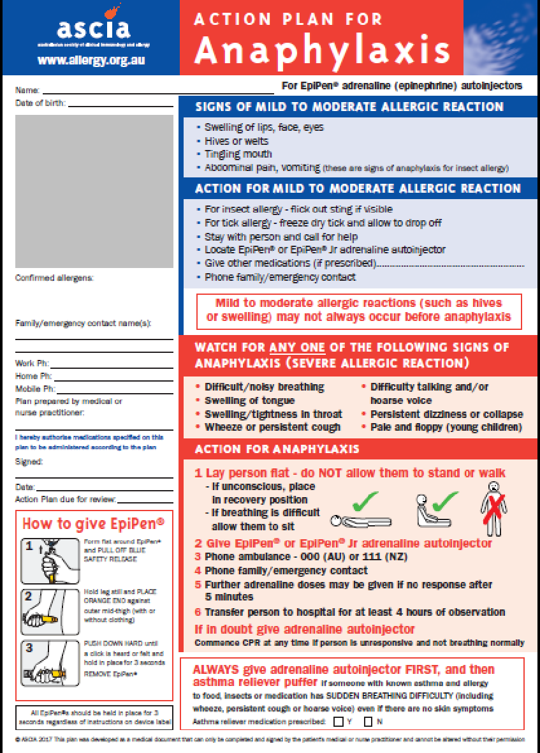
Parents and guardians (via their medical practitioner) can access the ASCIA Action Plan from
https://www.allergy.org.au/health-professionals/ascia-plans-action-and-treatment

This Individual Anaphylaxis Management Plan will be reviewed on any of the following occurrences (whichever happen earlier):
- annually
- if the student's medical condition, insofar as it relates to allergy and the potential for anaphylactic reaction, changes
- as soon as practicable after the student has an anaphylactic reaction at school
- when the student is to participate in an off-site activity, such as camps and excursions, or at special events conducted, organised or attended by the school (e.g. class parties, elective subjects, cultural days, fetes, incursions).
I have been consulted in the development of this Individual Anaphylaxis Management Plan.
I consent to the risk minimisation strategies proposed.
Risk minimisation strategies are available at Chapter 8 – Risk Minimisation Strategies of the Anaphylaxis Guidelines
Signature of parent:
Date:
I have consulted the parents of the students and the relevant school staff who will be involved in the implementation of this Individual Anaphylaxis Management Plan.
Signature of principal (or nominee):
Date:

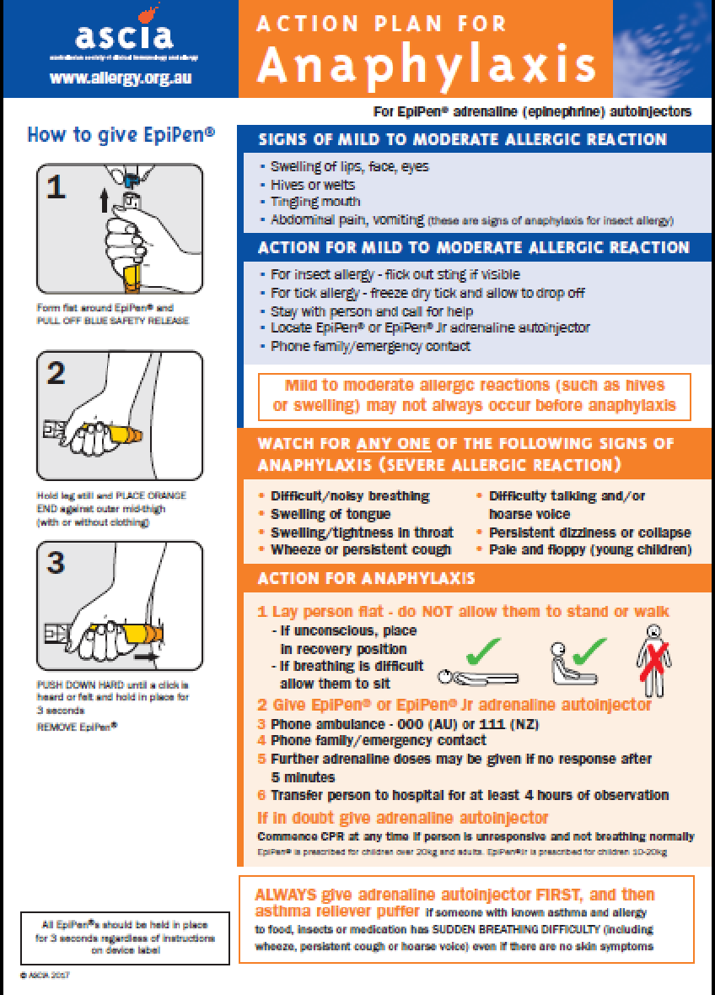
Appendix B
